Lab4 201533661 이승수 10/14

//p1)long double 사이즈미스, p2)

Problem1)sizeof

#include <stdio.h>

void main()

{

char a;

unsigned char b;

short int c;

unsigned short int d;

int e;

unsigned int f;

long int g;

unsigned long int h;

float i;

double j;

long double k;

printf(" char:%d\n unsigned char:%d\n short int:%d\n unsigned short int:%d\n int:%d\n unsigned int:%d\n long int:%d\n unsigned long int:%d\n float:%d\n double:%d\n long double:%d", sizeof(a), sizeof(b), sizeof(c), sizeof(d), sizeof(e), sizeof(f), sizeof(g), sizeof(h), sizeof(i), sizeof(j), sizeof(k));

}

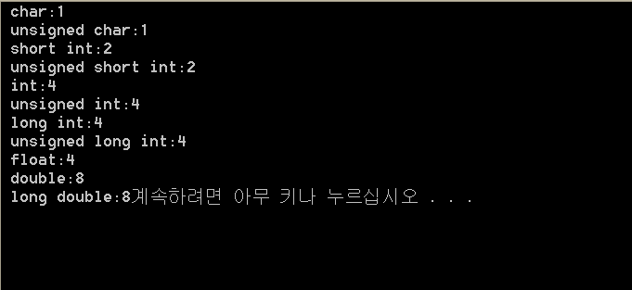

Problem2)

#include <stdio.h>

#include <stdlib.h>

struct person

{

char name[15];

char telephone[15];

char age[4];

};

void main()

{

struct person Person[10];

int i, menu;

FILE \*fp;

fp = fopen("nameage.dat", "w");

char name[15], telephone[15], age[4];

for (i = 0; i < 10; i++)

{

strcpy(Person[i].name, "unassigned");

strcpy(Person[i].telephone, "000-0000-0000");

strcpy(Person[i].age, "0");

}

for (i = 0; i < 10; i++)

{

fprintf(fp, "%s %s %s ", Person[i].name, Person[i].telephone, Person[i].age);

}//finish initialization

fclose(fp);

fp = fopen("nameage.dat", "r");

while (fscanf(fp, "%s %s %s", name, telephone, age) != EOF)

{

printf("%s %s %s\n", name, telephone, age);

}

fclose(fp);

while (1)

{

printf("add int[1(update&record) 2(exit)]:");

scanf("%d", &menu);//step2

if (menu == 1)

{

printf("num(1~10):");

scanf("%d", &i);

printf("%d.\nname:", i);

i -= 1;

scanf("%s", Person[i].name);

printf("telephone:");

scanf("%s", Person[i].telephone);

printf("age:");

scanf("%s", Person[i].age);

fp = fopen("nameage.dat", "w");

for (i = 0; i < 10; i++)

{

fprintf(fp, "%s %s %s ", Person[i].name, Person[i].telephone, Person[i].age);

}

fclose(fp);

fp = fopen("nameage.dat", "r");

while (fscanf(fp, "%s %s %s", name, telephone, age)!=EOF)

{

printf("%s %s %s\n", name, telephone, age);

}

fclose(fp);

}//step3

else

{

exit(1);

}//step4

}

}

